Hedge Fund_Final Exam – Review Notes _3
Date: 21 March 2026

Review Slides Review
- Strategy Risk Factors

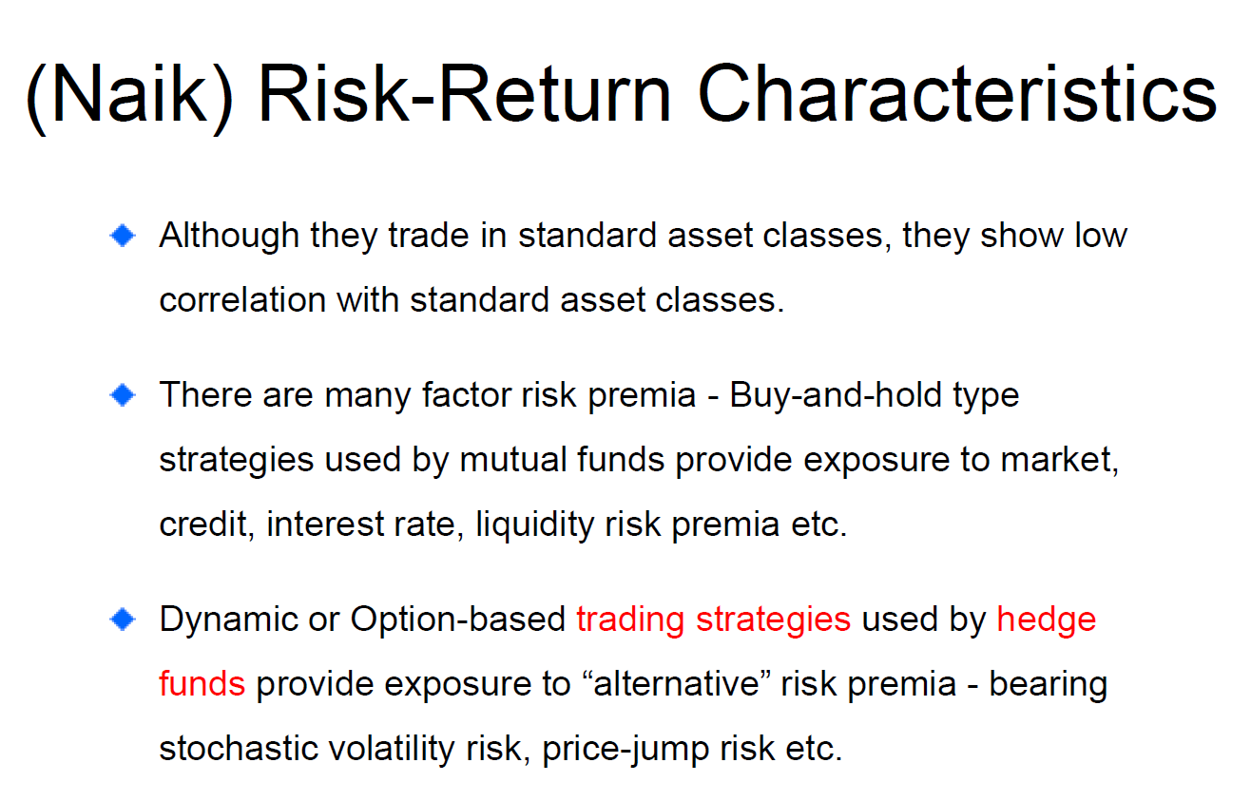

#1.1 Summary
The slide explains the risk-return characteristics of hedge funds, focusing on how their returns are driven not only by traditional asset class exposures but also by alternative risk factors. It highlights that although hedge funds trade in standard asset classes such as equities, bonds, and derivatives, their returns often exhibit low correlation with traditional markets. This is because hedge funds employ dynamic and active trading strategies rather than passive buy-and-hold approaches.
The slide distinguishes between traditional risk premia and alternative risk premia. Traditional investment strategies, such as those used by mutual funds, typically generate returns by exposure to systematic risk factors like market risk, credit risk, interest rate risk, and liquidity risk. In contrast, hedge funds generate returns through dynamic, option-like trading strategies, which expose them to more complex risks such as stochastic volatility risk, price jump risk, and non-linear payoff structures.
As a result, hedge fund returns may appear to generate alpha when evaluated using traditional linear models, but in reality, much of this “alpha” can be explained by exposure to these alternative risk premia. This explains why hedge funds can show low correlation with traditional asset classes while still being driven by systematic risk factors. The key implication is that understanding hedge fund performance requires identifying and modelling these underlying risk exposures rather than attributing returns purely to managerial skill.
Xxxxxxxxxxxxxxxxxxxxxxxxxxxxxxxxxxxxxxxxxxxxxxxxxxxxxx
These two slides introduce the topic of Strategy Risk Factors through Naik's framework of Risk-Return Characteristics of hedge funds. Together they make a fundamental argument about why hedge funds produce returns that look different from traditional investments — and it comes down to the nature of the risk premia they harvest.
The Three Core Points
The first bullet establishes what appears to be a paradox: hedge funds trade in standard asset classes — stocks, bonds, currencies, commodities — yet their returns show low correlation with those same asset classes. If a long/short equity fund trades stocks, why doesn't it behave like the stock market? The answer lies in the next two bullets.
The second bullet establishes the baseline: traditional factor risk premia. Buy-and-hold strategies used by mutual funds expose investors to well-known, well-compensated risks — market risk (equity premium), credit risk (corporate bonds over Treasuries), interest rate risk (duration), and liquidity risk (illiquid vs. liquid securities). These are linear, passive exposures. You earn these premia simply by holding the asset.
The third and most important bullet makes the key distinction: hedge funds use dynamic or option-based trading strategies that expose investors to fundamentally different risk premia — specifically alternative risk premia. The two highlighted examples are stochastic volatility risk and price-jump risk. These are risks that cannot be captured by passively holding assets. They require active, dynamic trading or options to access. This is precisely why hedge fund returns look uncorrelated with standard asset classes — they're not harvesting the same risks. They're harvesting different, more complex, less transparent risks through strategies that behave like options.
The red text highlighting "trading strategies" and "hedge funds" is the professor's visual emphasis of the key conceptual link: it is the strategy that generates the alternative risk exposure, not the asset class itself.

{Memory}
👉 Hedge funds:
- Low correlation ≠ low risk
- Just different risks
👉 Two types of return:
- Traditional beta (market, credit, rates)
- Alternative beta (volatility, jumps, liquidity)
👉 Key insight:
- Alpha often = hidden risk premia

Conclusion
Hedge fund returns appear to generate alpha largely because traditional models fail to capture their exposure to alternative risk premia, meaning that much of observed alpha may in fact be compensation for complex, non-linear risks rather than true managerial skill.

#3 Naik: Equity Long vs L/S
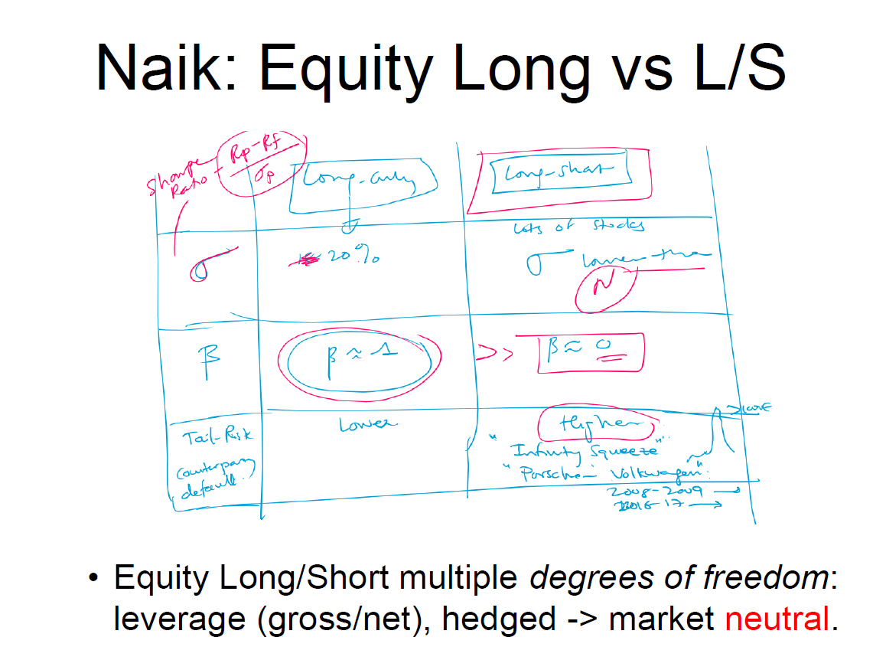
State Dependent Returns: Trend Followers
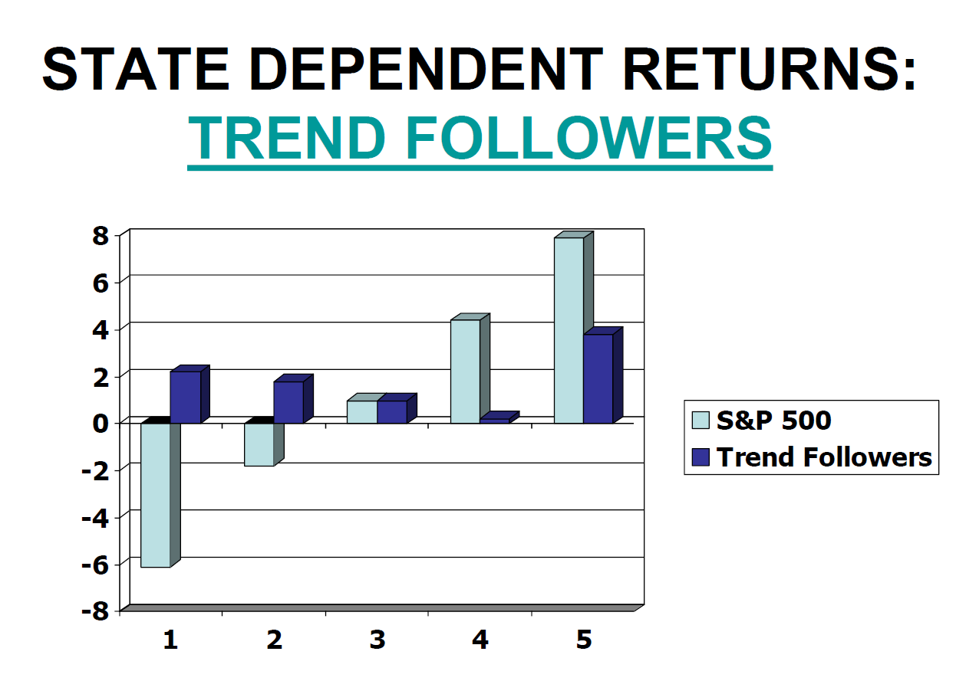
https://www.abbeycapital.com/2025-annual-review/

State Dependent Returns: HFR Fixed Income Arbitrage

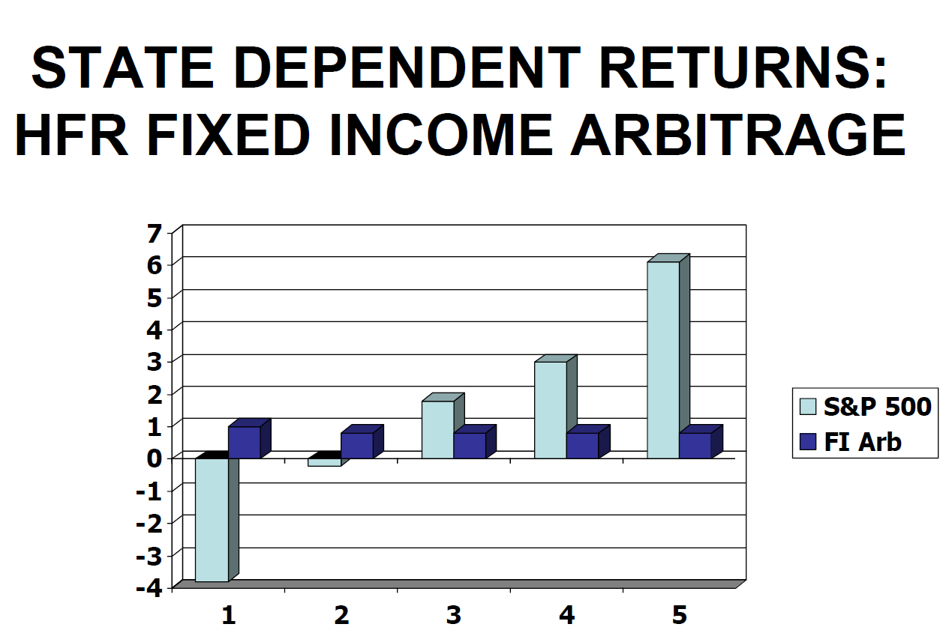

#3.1 Summary
Chart 1 - State Dependent Returns — HFR Fixed Income Arbitrage
The horizontal axis shows 5 market states ranked from worst (State 1, extreme market stress) to best (State 5, strong bull market), based on S&P 500 performance quintiles. The bars compare the S&P 500 return (light blue) against Fixed Income Arbitrage returns (dark blue) in each state.
The pattern is striking and highly asymmetric. In State 1 (worst equity environment), the S&P 500 drops roughly -4%, while FI Arb also loses approximately -0.5% to -1% — a small loss but a loss nonetheless, precisely when investors need protection most. Across States 2 through 5, FI Arb returns are remarkably flat and stable, hovering around +0.5% to +0.8% regardless of whether equities are mildly down, flat, or surging +6% in State 5. The defining feature is the complete absence of upside participation — when equities boom in State 5, FI Arb barely moves — combined with correlated losses in the worst state. This is the classic short-put payoff profile: collect steady premium in all normal states, but suffer disproportionate losses precisely in crisis conditions.

Chart 2: State Dependent Returns — Trend Followers
The same framework applies. In State 1 (worst equity environment, S&P down ~-7%), Trend Followers return approximately +2% — genuine crisis protection. In State 2 (mild equity weakness), Trend Followers still generate a small positive return (~+1.5%). Across States 3 and 4, returns are modest. In State 5 (strongest equity environment), Trend Followers generate approximately +4%, participating meaningfully in bull markets too.The profile is essentially the opposite of FI Arb — it resembles a long straddle or long options position: making money in extreme market moves in either direction, generating positive returns in both the worst and best equity environments. This is the mechanical explanation — trend followers go long rising markets and short falling ones, so extreme directional moves in either direction tend to be profitable.Chart 3: Naik — Equity Long vs Long/Short (Hand-Drawn)This professor's sketch compares Equity Long Only versus Equity Long/Short along four dimensions laid out in a grid:
- Sharpe Ratio (Rp-Rf/σ): Long Only has some Sharpe, Long/Short potentially higher despite lower N (fewer stocks in universe)
- Alpha: Long Only generates some alpha (~20% noted), Long/Short can generate alpha with β≈1 on the long side and β≈0 net — the hedge neutralizes market exposure
- Beta: Long Only has β≈1 (full market exposure), Long/Short has β≈0 (market neutral possible)
- Tail Risk: Long Only has counterparty/default tail risk; Long/Short has higher tail risk from events like "infinity squeeze," with Porsche/Volkswagen 2008-2009 and GameStop 2016-17 cited as real examples of short squeezes destroying L/S funds
The bottom bullet summarizes: Equity L/S has multiple degrees of freedom — you can dial leverage (gross vs net), and hedge all the way to market neutral.

{Memory}
State-dependent returns =
- Performance depends on market regime
Strategy intuition:
- Fixed income arb → stable, BUT crash risk
- Trend following → crisis alpha
Equity L/S:
- Flexible beta
- Can be market neutral
Conclusion
Hedge fund strategies exhibit state-dependent, non-linear return profiles, where performance varies across market regimes, implying that diversification across strategies with complementary exposures is essential for effective portfolio construction.

#4 Convertible Arbitrage
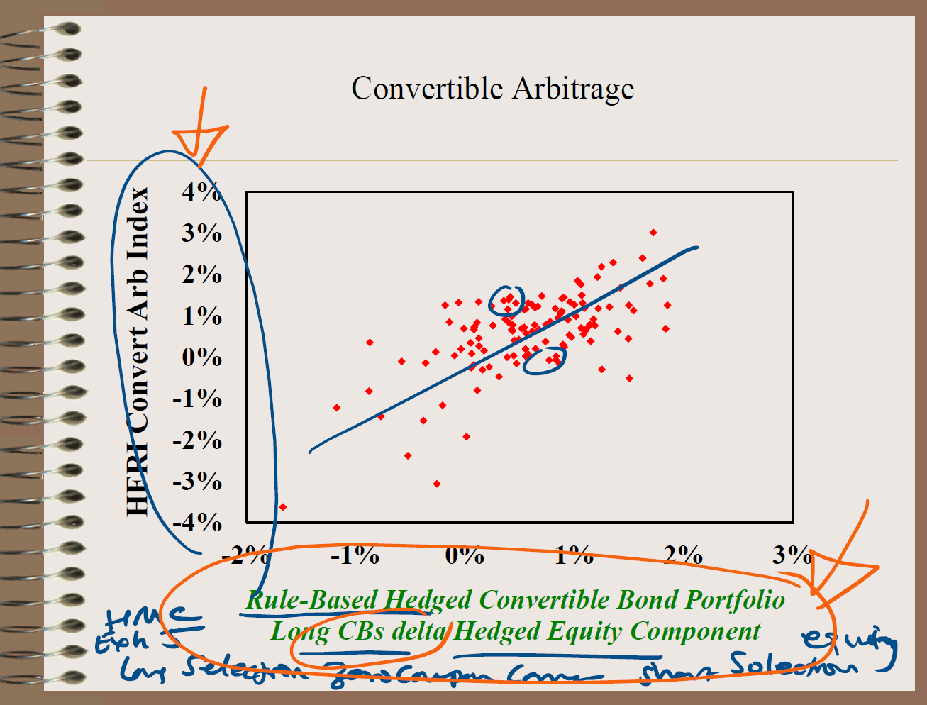

#4.1 Summary
This slide presents a scatter plot titled "Convertible Arbitrage" that is one of the most conceptually rich diagrams in the course. It directly visualizes the relationship between a rule-based, systematic replication strategy and actual hedge fund returns — and asks how much of what convertible arbitrage funds earn is genuine alpha versus replicable alternative beta.
The Chart
The vertical axis shows the HFRI Convertible Arbitrage Index returns — the actual returns of real convertible arbitrage hedge funds. The horizontal axis shows the returns of a Rule-Based Hedged Convertible Bond Portfolio: a systematic strategy that goes long convertible bonds (CBs) while delta-hedging the equity component — removing the directional equity exposure to leave only the bond, volatility, credit, and liquidity components. Each red dot represents a monthly observation of both return series simultaneously.
The blue regression line slopes upward with a clear positive relationship, indicating that the systematic rule-based strategy explains a significant portion of actual hedge fund returns. The R-squared of this relationship is visually substantial — the dots cluster reasonably around the line, suggesting the replication captures the majority of what these funds actually do.
The Two Circled Clusters
The professor has drawn two blue circles highlighting specific data points. The left circle captures observations where the actual fund index returned around 1-1.5% while the rule-based strategy returned approximately 0% — these are points above the regression line, representing periods when real hedge funds outperformed the systematic benchmark. This is the region of potential genuine alpha — where manager skill in bond selection, zero-coupon conversion, and short equity selection added value beyond what the rule could capture. The right circle captures a cluster where both strategies performed similarly in the 0% region — essentially confirming the benchmark relationship.
The Professor's Annotations
The orange arrow at the top left pointing down toward negative territory on the vertical axis highlights the region of large drawdowns for the actual index — the catastrophic left-tail events (2008 crisis, convertible bond market freezing) where the index plunged to -4%. The annotation at the bottom in blue ink references HMC (Harvard Management Company), Eth S (ethical screening?), and specifically: "Long Selection, Zero Coupon Conv[ertibles], Short Selection, Equity" — these are the four alpha sources in convertible arbitrage that a skilled manager can exploit beyond the mechanical rule. The orange annotation at the bottom right references equity and short selection — emphasizing that the short equity component and selection of which convertibles to hold are where discretionary alpha resides.
Xxxxxxxxxxxxxxxxxxxxxxxxxxxxxxxxxxxxxxxxxxxxxxxxx
The slide presents a scatter plot comparing the returns of a hedge fund convertible arbitrage index (y-axis) with the returns of a rule-based hedged convertible bond portfolio (x-axis). The rule-based strategy consists of going long convertible bonds and delta-hedging the equity component, effectively isolating the bond and volatility characteristics of the instrument.
The scatter points show a clear positive linear relationship, indicating that a large portion of hedge fund convertible arbitrage returns can be explained by this systematic, rule-based strategy. The fitted line suggests that the hedge fund index behaves similarly to the replicated portfolio, implying that much of the return is driven by systematic exposures rather than pure alpha.
However, the dispersion of points around the line indicates that there are still deviations, which may reflect manager skill, timing, execution, or additional risk exposures. The slope of the relationship suggests sensitivity to underlying market factors such as equity movements and credit conditions, while the intercept can be interpreted as residual alpha.
Overall, the key takeaway is that convertible arbitrage returns are largely replicable using a mechanical strategy, supporting the idea that a significant portion of hedge fund returns comes from alternative beta, not pure skill.

#5 Manager Selection
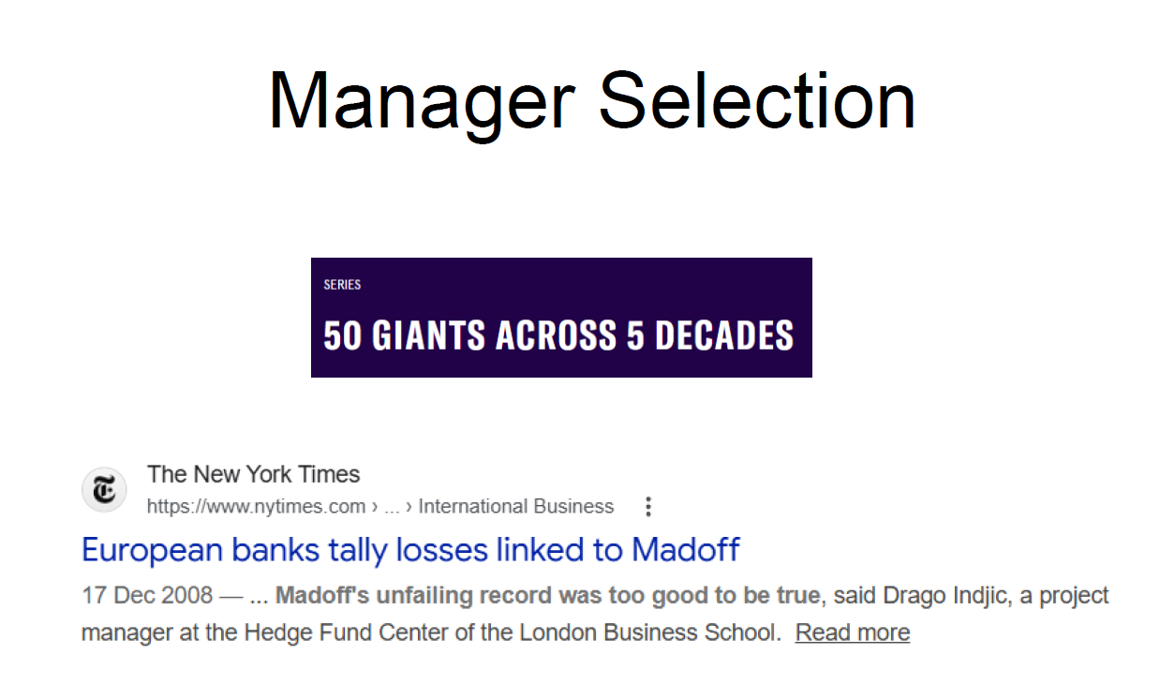
https://www.nytimes.com/2008/12/17/business/worldbusiness/17iht-17exposure.18747038.html
https://thehedgefundjournal.com/50-giants/

#5.1 Summary
The slide is titled "Manager Selection" and uses two carefully chosen references to frame the entire challenge of selecting hedge fund managers: a celebratory piece on the industry's greatest successes, and one of the most catastrophic failures in financial history.
The "50 Giants Across 5 Decades" Reference
This is from the Hedge Fund Journal's series profiling the 50 most significant hedge fund managers across the industry's history — figures like George Soros, Ray Dalio, Paul Tudor Jones, and David Simons. The implicit point is that identifying these managers in advance is the holy grail of manager selection. In hindsight, their track records look obvious. In real time, distinguishing a genuinely skilled manager who will compound returns for decades from one who is lucky, running a Ponzi scheme, or simply harvesting risk premia that will eventually blow up is extraordinarily difficult. The "50 Giants" framing asks: what due diligence process would have correctly identified these managers at the start of their careers, before their greatness was evident?
The Madoff / NYT Reference
The New York Times article from December 17, 2008 covers European banks tallying losses linked to Bernard Madoff's fraud — the largest Ponzi scheme in history, approximately $65 billion. The quote highlighted is devastating in its simplicity: "Madoff's unfailing record was too good to be true," attributed to Drago Indjic, a project manager at the Hedge Fund Centre of the London Business School — Naik's own institution. This is the professor citing his own center's commentary on the biggest failure of manager selection in history.
The juxtaposition is deliberate and powerful. On one side: 50 genuine giants who delivered extraordinary returns over decades. On the other: a fraudster whose returns were so consistent, so smooth, and so impressive that sophisticated European banks and institutional investors failed to detect the fraud. The same qualities that make a great manager look attractive — consistent returns, low volatility, uncorrelated performance — are also the qualities a fraud can simulate. Manager selection is therefore not just about finding skill; it is fundamentally about distinguishing genuine skill from fraud, luck, and disguised risk-taking, which requires rigorous operational and investment due diligence that goes far beyond analyzing return statistics.
Xxxxxxxxxxxxxxxxxxxxxxxxxxxxxxxxxxxxxxxxxxxxxxxxxxxxxxxxxxxxxxxxxxxxxxx
The slide focuses on the challenges of hedge fund manager selection, using two powerful real-world references: the “50 Giants Across 5 Decades” (highlighting historically successful managers) and the Bernard Madoff scandal, where investors suffered large losses despite the appearance of consistent and strong performance. The contrast illustrates a key issue in hedge fund investing: distinguishing genuine skill from misleading performance.
The inclusion of the Madoff case highlights that even sophisticated investors and institutions can fail in due diligence, relying too heavily on track record, reputation, and perceived stability. Madoff’s returns appeared unusually smooth and consistently positive, which should have raised red flags but instead attracted significant capital. This demonstrates that performance alone is not a reliable indicator of skill.
The “50 Giants” reference suggests that while some managers do achieve long-term success, identifying them ex ante is extremely difficult. Survivorship bias and hindsight bias make successful managers appear obvious after the fact, but in reality, many funds fail or underperform.
Overall, the slide emphasises that manager selection is inherently difficult, and requires deep due diligence beyond performance metrics, including operational risk assessment, strategy understanding, and skepticism toward unusually consistent returns.

(Memory)
FINAL MEMORY FRAME (CRITICAL)
>Manager selection problem:
- Skill vs luck vs fraud
> Madoff lesson:
- Smooth returns = 🚨 red flag
> Key biases:
- Survivorship
- Backfill
- Hindsight
> Key insight:
- Performance ≠ skill

Conclusion
Hedge fund manager selection is challenging because performance data is noisy, biased, and often misleading, requiring investors to rely on comprehensive due diligence rather than past returns alone.

Manager Selection
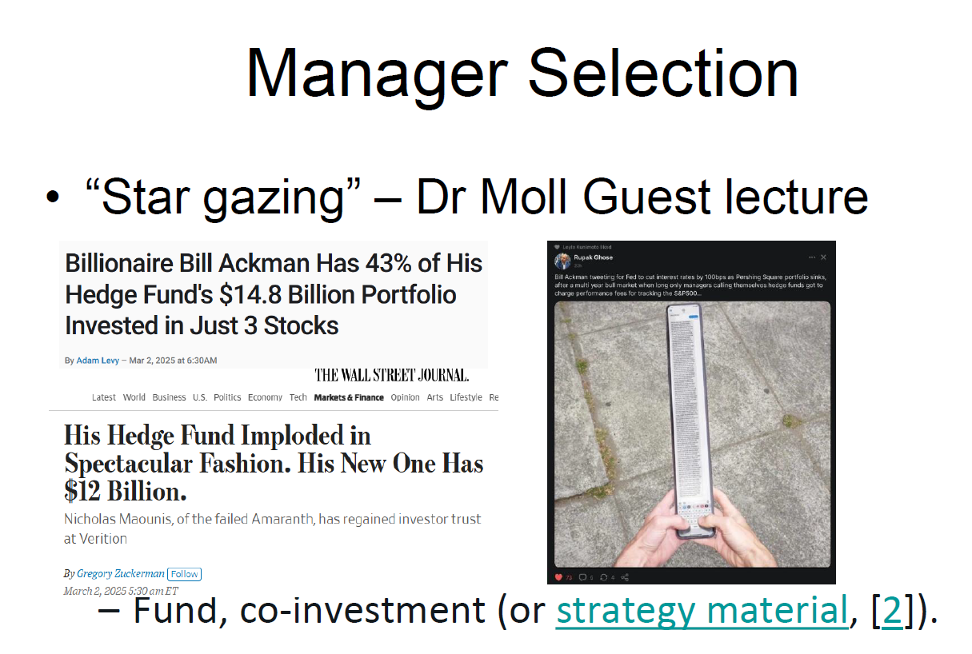
https://www.fool.com/investing/2025/03/02/billionaire-bill-ackman-has-43-of-his-hedge-funds/
https://www.wsj.com/finance/investing/his-hedge-fund-imploded-in-spectacular-fashion-his-new-one-has-12-billion-0e67192f
https://www.linkedin.com/posts/antongolub_you-asked-me-to-explain-how-michael-saylor-activity-7294324159302529024-At_n/?skipRedirect=true

An investment Committee
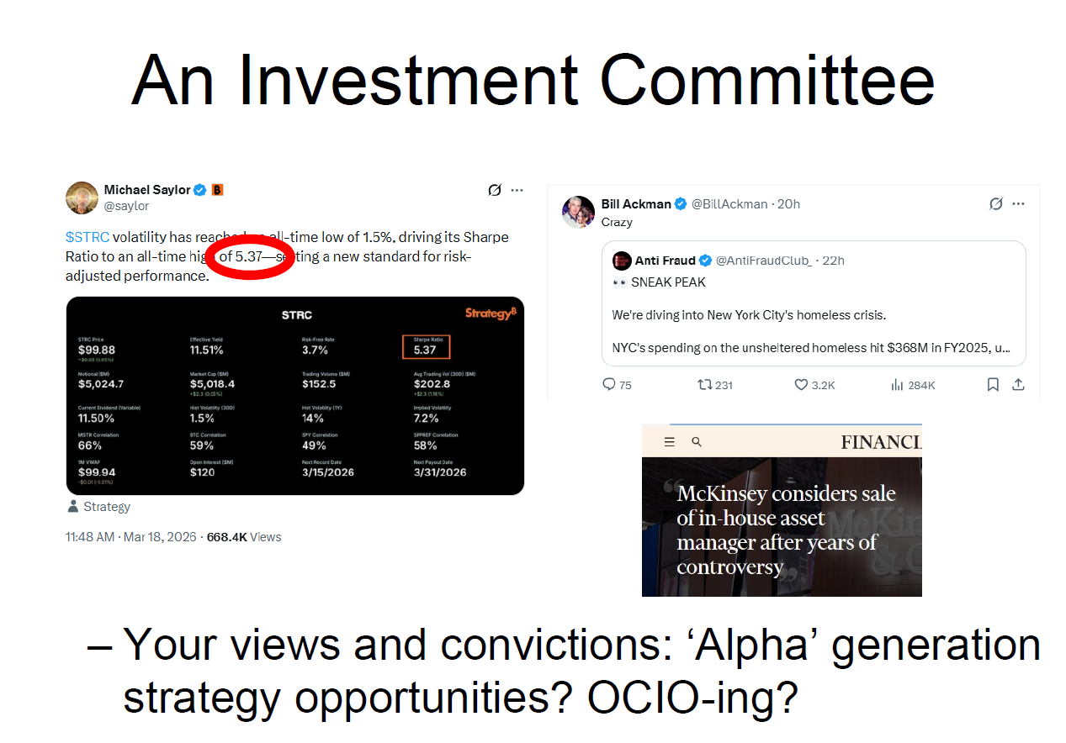

  - Your views and convictions: ‘Alpha’ generation strategy opportunities? OCIO-ing?

  - https://www.ft.com/content/8050dc39-8444-4811-be37-8750141b4d46?syn-25a6b1a6=1
  - https://x.com/BillAckman/status/2034321487260246032?s=20
  - https://x.com/saylor/status/2034235533010886812

  - Manager Selection
  - 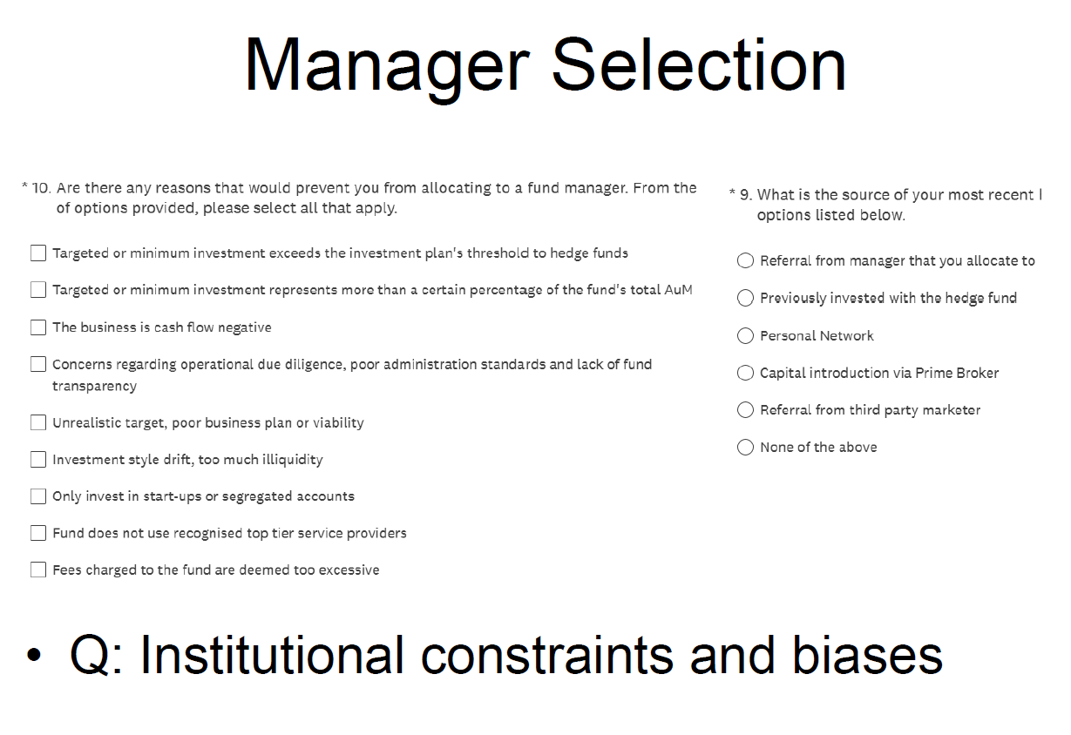
  - #Summary
  - This slide continues the Manager Selection theme but shifts from the theoretical (how to identify great managers) to the practical and behavioral — specifically, what institutional constraints and biases actually prevent investors from allocating to managers they might otherwise want to back, and how investors actually discover new managers in the first place.
  - The slide presents two survey questions, likely from the AIMA Emerging Manager Survey referenced in earlier slides, which together illuminate the gap between rational manager selection theory and what actually happens in practice.
  - Question 10 — Reasons Preventing Allocation (Left Panel)
  - This is a checklist of reasons that would prevent an institutional investor from allocating to a fund manager. Reading through them carefully reveals the full landscape of practical barriers:
  - Minimum investment exceeds the plan's threshold — a pure size constraint; many institutional mandates cap total allocation to any one fund as a percentage of the fund's AUM or as an absolute dollar minimum, immediately excluding small funds
  - Minimum investment represents too large a percentage of the fund's total AUM — the concentration risk problem; if a $100M allocation would represent 50% of a $200M fund, the investor has too much influence and too little liquidity
  - The business is cash flow negative — the fund is pre-revenue, burning through the manager's personal capital; viability concern
  - Operational due diligence concerns, poor administration, lack of transparency — the Madoff lesson applied; this is the governance filter
  - Unrealistic target, poor business plan or viability — the manager doesn't have a credible path to institutional scale
  - Investment style drift, too much illiquidity — the fund is doing something different from what it said it would do, or is locked up longer than acceptable
  - Only invests in start-ups or segregated accounts — some investors have mandates restricting them to commingled funds only
  - Does not use recognised top-tier service providers — prime brokers, administrators, auditors must be credible institutional-grade firms
  - Fees deemed too excessive — a direct fee sensitivity filter
  - Question 9 — Source of Most Recent Hedge Fund Investment (Right Panel)
  - This asks how investors actually found their most recent hedge fund investment. The options are: referral from a manager already in the portfolio, previously invested with the fund, personal network, capital introduction via prime broker, referral from a third-party marketer, or none of the above.
  - The Bottom-Line Bullet
  - The professor's synthesis: "Q: Institutional constraints and biases." This is both a description and a critical question. The checklist of allocation barriers isn't neutral — it systematically excludes small, emerging, and innovative managers while favoring large, established, institutionally-packaged funds. The sourcing question reveals that manager discovery is heavily relationship-driven rather than merit-driven. Together, these two surveys demonstrate that institutional capital allocation is shaped as much by organizational constraints, career risk, and relationship networks as by investment skill assessment.

Xxxxxxxxxxxxxxxxxxxxxxxxxxxxxxxxxxxxxxxxxxxx
The slide presents a survey-style framework highlighting the key reasons why investors may choose not to allocate capital to a hedge fund manager, as well as how they source investment opportunities. The left-hand side lists constraints such as minimum investment size, concentration limits, poor operational due diligence, lack of transparency, unrealistic business plans, style drift, illiquidity, weak service providers, and excessive fees. These represent institutional constraints, meaning that even if a fund has strong performance, it may still be excluded due to structural or governance requirements.
The right-hand side highlights how investors actually find managers, including referrals, prior relationships, personal networks, and capital introduction via prime brokers. This illustrates the presence of selection biases, where access to capital is influenced not only by skill but also by networks, reputation, and distribution channels.
The key insight of the slide is that capital allocation is not purely driven by performance or alpha, but is heavily shaped by institutional rules and behavioral biases. As a result, some skilled managers may fail to attract capital, while others may succeed due to better access or relationships. This creates inefficiencies in the hedge fund industry and reinforces the idea that investor money is not perfectly “smart.”
MEMORY
Allocation ≠ purely performance-driven
Two big frictions:
- Institutional constraints
- Behavioral / network biases
Result:
- Capital ≠ always to best managers

Exam-winning sentence
Hedge fund capital allocation is shaped not only by performance but also by institutional constraints and behavioural biases, meaning that even sophisticated investors may fail to allocate capital efficiently.

